Wii Educational Tools Design Report
Team “Wii Can Do It!”
Kyle Shepard
Joseph Cirone
Gilliane Oswald
Chris Loew
Seth Daugherty
Introduction
CSCI 101 is a new class being offered next semester that is designed to give students a general understanding of basic computer science concepts. To make the class more interactive and engaging for students, our client, Keith Hellman, is looking to design several games that interface with Nintendo Wii controllers (“Wiimotes”). It is the goal of team “Wii Can Do It!” to develop a Wiimote framework that will handle the controller input and its interaction with the game. This framework will allow future Wii game developers to focus solely on the game logic. It is also our goal to use this framework to develop two initial games, one where teams of players are racing to balance a binary tree, and one where players cooperate to route packets on a simulated network.
System Design
The high level design of this project has four main components: the Wii Event Parser, the Game Event Parser, the Network Routing Game, and the Binary Tree Game.

The Wii Event Parser interacts directly with the Wiimotes. This module gathers the raw data from the Wiimotes and converts it to a standardized format we have dubbed a “Wii Event.” The Game Event Parser accepts these Wii Events and then converts them to the appropriate “Game Event” or, more precisely, the appropriate function call within the game. The modules are the actual games described above. The details of these modules are explored below.
- Wii Event Parser
The actual Wii Event Parser class will be abstract to allow several formats of raw Wiimote data. The Wii Event Parser will contain abstract methods to allow creation of Wii Events and sending the events over a network socket. Currently, the Wii Event Parser will have two child classes, one to convert the raw Bluetooth data received from the Wiimotes and one to read from a network socket. See Figure 1. To read the Bluetooth data from the Wiimotes, the parser will interface with the open source program cwiid. The network socket, however, will use our own command set to generate appropriate Wii Events.
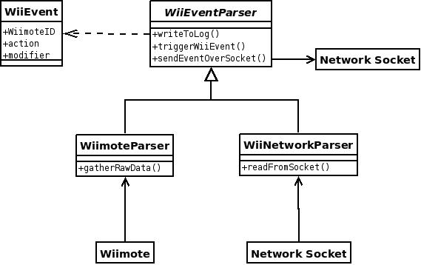
Figure 1: The Wii Event Parser Module
These classes will overwrite the triggerWiiEvent method to create “Wii Event” objects from their respective sources. Wii Events are intended to represent the simplest action a user would perform with the Wiimote. Examples of Wii Events would be “press a”, “release a”, “flick right”, and so on. Here is a list of Wii Events our framework will support. This list can very easily be expanded to support other types of Wii Events such as input from the Wii Nunchuck attachment.
- buttons (up, down, left, right, a, b, +, -, 1, 2, home)
- “flick” (x, y, z)
- roll
- pitch

Each Wii Event holds three pieces of information, the ID of the Wiimote (an arbitrary number assigned when a Wiimote is connected), the name of the event (“A”, “FlickX”, “Roll”), and a modifier. This modifier will hold different information depending on the action that triggered the Wii Event.

Buttons:
For button events, the modifier is simply +1 or – 1 to determine whether the button was pressed or released.

Flicks:
For flick events in any of the three directions, the modifier will be a positive or negative number with the sign determining direction along the specific axis. The magnitude of the modifier is equal to the peak magnitude of the flick given by the accelerometer sensor.

Roll and Pitch:
For roll and pitch events, the initial plan was to send a modifier similar to the modifier for flick events with a sign denoting direction and magnitude denoting magnitude of the actions. Instead, the modifier is merely a +1 or -1 to designate direction of the roll aka the sign determines whether it is a positive roll (counter-clockwise) or negative roll (clockwise).

The magnitude of pitch and roll events is discarded because we chose to discretize the continuous stream of pitch and roll data into a set of Wii Events representing a very small change in value. In other words, a roll event is triggered after the Wiimote shifts 0.1 radians from the position of the last roll event. So, if the Wiimote is level (i.e. roll = 0) and the player rotates to 0.35 radians, then the Wii Event Parser will send out 3 separate roll events with a +1 modifier to designate its rolling clockwise. The next roll event would occur when the roll is >= 0.4 radians or <= 0.2 radians. The same threshold-based mechanism is used for pitch events.

Flick events will also only be fired after the acceleration is faster than a certain threshold. This should weed out minor changes in Wiimote data that are likely due to normal human movement rather than intentional gameplay actions.

Once a Wii Event has been triggered, the Wii Event Parser sends the Wii Event over a network socket to the Game Event Parser.

2. Game Event Parser
The Game Event Parser is intended to be an interface between game logic and combinations of Wii Events. The Game Event Parser makes it very simple for game developers to bind sequences of Wii Events to a game function call without having to rewrite the logic that listens for combinations of Wii Events. Developers only have to create a Python file of bindings, which is simply a function name associated with a sequence of Wii Events. The Game Event Parser will take this list of bindings, listen for Wii Events from the Wii Event Parser, and call the proper function when the corresponding sequence of Wii Events is received.
For a more concrete explanation, consider the following list of bindings, which is very similar to the actual syntax for declaring bindings.
bind_functionA = ['pressA', 'releaseA']
bind_functionB = ['pressB', 'flickX', 'releaseB']
bind_functionC = [ ['pressA', 'pressB'], 'flickX', ['releaseB', 'releaseA']]

The first binding connects a function called functionA in the game logic to a simple press of the A button. The middle binding represents selecting something and flicking it left or right, an action we will use several times in our games. The last binding shows the flexibility of the Game Event Parser. Bindings can be composed of Python's collection data types to represent different variations of events. In this case, the list ['pressA', 'pressB'] indicates that the A and B buttons should be pressed simultaneously.

A high level overview of the Game Event Parser is in Figure 2. The program is constantly listening for Wii Events. Every time it receives one, it iterates through the list of bindings looking for sequences that match the received Wii Event. For each event binding, the parser stores a pointer to the next event in the sequence. If the received Wii Event matches the binding's next pointer, the program will move the pointer to the next event in the binding's sequence. If the received Wii Event does not match this pointer, then the user is performing a different sequence of actions, so the program resets the pointer to the beginning of the binding's event sequence.
The Game Event Parser relies heavily on Python's dynamic typing scheme. Since lists in Python do not care what type of data they store, our bindings can be very flexible. Game developers can specify a set of Wii Events that should happen simultaneously simply by inserting a list inside the binding's event sequence list. Another unique Python feature the Game Event Parser uses is every object's power of introspection. The list of bindings is actually a subclass of the main Game Event Parser class. The object will look at all of its internal member functions and variables. Variables that are prefixed by a specified word are considered to be bindings, so they are all gathered into a list to allow easy iterating. When a game function needs to be triggered, the Game Event Parser changes the scope of the variable name to the game class and calls the corresponding game class method.

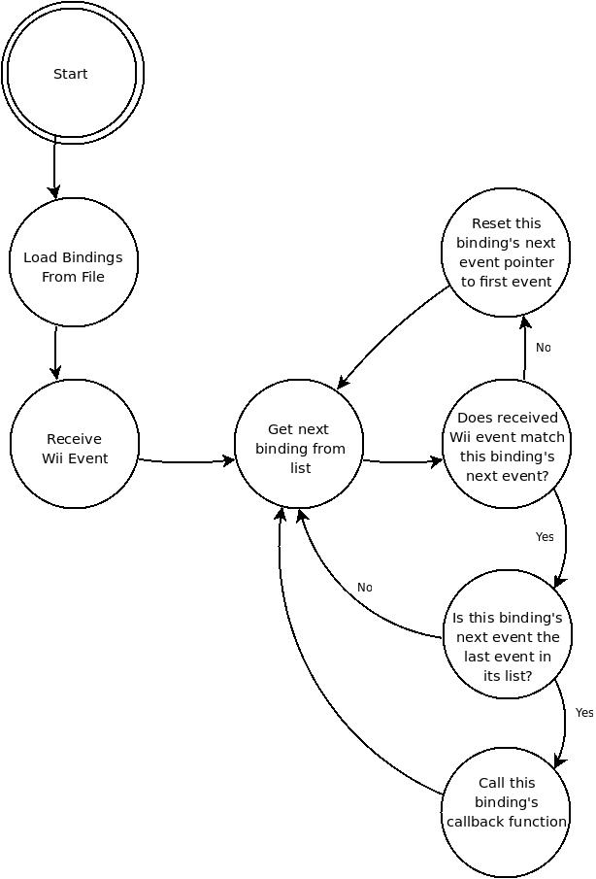
Figure 2: The Game Event Parse Finite State Machine
3. Network Routing Game
The Network Routing Game will have three major classes: the RouterNode class, Player class, and Map class. The RouterNode class represents a node in the network which can have up to 3 packets attached to it in a queue (since there are no queues in Python this is actually a collection but it functions the same). The RouterNode also has a 'color' variable associated with it and functions to both send and receive packets, which are merely colors. The Player class holds a Wiimote ID (to specify what Wiimote receives the player's actions) and a color to represent what node the player controls. The final class is the Map class, which holds the actual layouts for each level (i.e. all the nodes, the edges between the nodes, and the weights of those edges). The Nodes will likely be stored in a list, while the edges will be stored as a list of dictionaries. Each dictionary will hold two Nodes and a string “weight” as keys. The values associated with the Node keys will be the directions along the X and Y axes of the edge in relation to the node (e.g., for an edge diagonal between two nodes, the direction value would be (1, 1) from one node to its neighbor and (-1, -1) for the neighbor back to the original node). The string “weight” key will be mapped to the actual numeric weight of the edge. The Map class will provide the functionality for nodes to check their neighbors and the direction to their neighbors.
The gameplay design for the routing game is rather simple, as illustrated in Figure 3. When players connect their Wiimotes, they are assigned a color; this color also designates which node in a map the player will control. Once all players have chosen their color and a level has been selected, the map will appear and packets will randomly appear on the screen at random nodes. Players must then ‘flick’ their Wiimotes in the direction of a neighboring node to route packets to the node with the same color. Score is determined by the weight of each edge used, so the lower the score the more efficient the routing (i.e., the lower the score, the better the team did). Some maps may have more nodes than the number of players; in this case, a simple script will control the non-player nodes and will send packets along the most efficient route automatically.
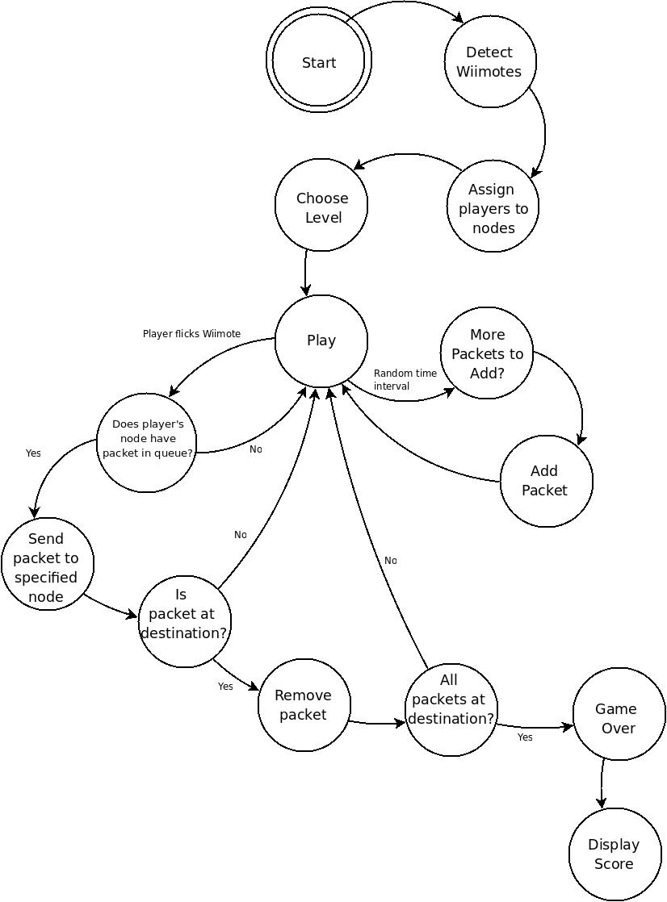
Figure 3: Network Routing Game Finite State Machine
4. Binary Tree Game
The Binary Tree Game has three main classes, the Player, Team, and Tree classes. The Player class is an abstract class that contains a ‘Wiimote ID’ to connect the player to a Wiimote and abstract functions for all the game actions players can take. These methods will be defined in its three children classes, one for each role in the game: sorter, inserter, and rotator. This allows the same Wiimote inputs to do different actions based on a player’s role. The Team class holds pointers to all three of its players and their gameboard, which consists of the opposing team’s 'queue' that the team’s ‘sorter’ will be altering and their own tree, which the team’s inserter and rotator will be altering. The Tree class holds most of the central game methods specifically checking if the tree is balanced and allowing rotation within the tree.
The gameplay design for the Binary Tree Game is significantly more complex than the routing game. For a state-based description, see Figure 4. To start, players will connect their Wiimotes and then begin the game. Once this happens, a dialog will appear that prompts a player to fulfill each role for each of the two teams. These roles are sorter, inserter, and rotator. Once all 6 roles (one of each role for each team) are filled, the actual game begins.
Each team gets a random sequence of 6 or 14 numbers (so the balanced tree is always full) to sort and a random number as the root of their tree. The sorter will be trying to sort the opposing team’s sequence of numbers so that they spend the most time rotating the tree after insertions, giving the sorter’s team more time to finish their tree. This sequence of numbers acts as a queue so that, whenever the tree is in a balanced state, the first number in the sequence and be placed in the ‘insertion slot’. This ‘insertion slot’ is simply a space on the screen to tell the inserter for each team that they need to insert that number into their team’s tree before they can continue. The inserter does this by flicking the Wiimote left or right to sort the node; the number then moves to the next node if it was sorted correctly (ie the player motioned left if the insertion number is less than the node at or right if greater) otherwise there will be an animation that designates the player made the wrong choice and the insertion restarts.
This continues until the insertion number is a leaf of the tree, at which point the game will check if the tree is still balanced or not. If it is balanced, the first number of the team’s sequence will get placed in the insertion slot and the game starts over again. If the tree is not balanced, player 3 must rotate the tree so that it becomes balanced. Player 3 does this by selecting a node (pressing the A button while their cursor is on the node) and then rolling the Wiimote in the desired direction and then letting go of the node (releasing the A button). However, if, by rotating the tree, the players have actually made it harder on themselves, the tree will reset and let the player try again, similar to how insertion restarts if they insert the number so the tree is not sorted. This process continues until a team reaches a balanced tree and has no numbers in their queue. At this point, that team has won, and the game returns to the main screen so play may continue if users wish.
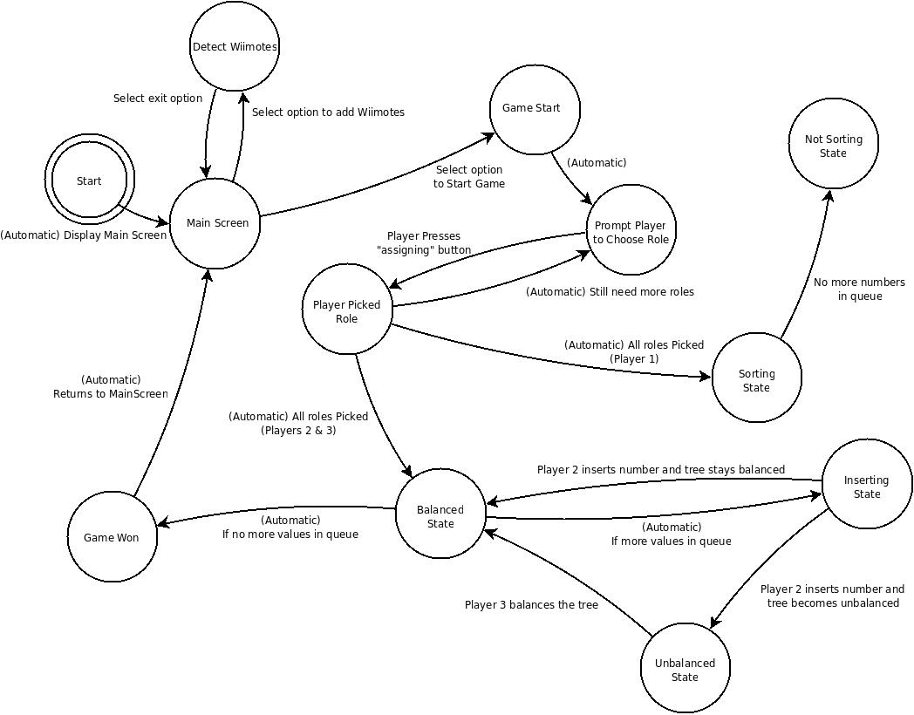
Figure 4: Binary Tree Finite State Machine

Testing
For testing, we will be using unit tests for all modules. For the games, this will primarily deal with the actual game logic rather than the GUI interaction. These tests will be implemented in the form of unit tests. For the parsers, since exactly re-creating input with a Wiimote would be rather difficult, all incoming data will be written to a log. While this is primarily for debugging, this also provides a way to provide test input and will be the main method for supplying test input to both Parsers. This log will be sent over a local network socket to the specific Parser in question.
When the games have neared completion, we will be conducting actual gameplay testing. We hope to have people unfamiliar with our system to provide feedback and evaluate the playability of our games.

Schedule
This Gantt chart shows the amount of time we will be dedicating to each of the tasks.
 |  |  | Week 3 |  |  |  |  | Week 4 |  |  |  |  | Week 5
 | M | T | W | Th | F | M | T | W | Th | F | M | T | W | Th | F
Wii Event Parser
Game Event Parser
Routing Game Logic
Learn PyGame
Routing Game GUI
Glue WEP and GEP
Glue WEP and GEP to RG
Binary Tree Game Logic
Binary Tree GUI
Documentation

Notes: - PyGame is a graphics library we will be using to build the GUIs
- WEP is short for Wii Event Parser
- GEP is short for Game Event Parser
- RG is short for Routing Game
- The gray blocks indicate where we would like to be, but can be shifted to accommodate more pressing matters

